Ex.no:4 | EXPLORATORY DATA ANALYSIS (EDA) – DATA INSPECTION, FILTERING, STATISTICAL ANALYSIS AND CORRELATION

Aim:
To perform data inspection, conditional filtering, sorting, statistical summary, group aggregation, correlation analysis, and data visualization on a hotel bookings dataset using Pandas and Matplotlib.

Algorithm:
- Start.
- Import the required Python libraries: pandas and matplotlib.pyplot.
- Load the dataset hotel_bookings.csv into a pandas DataFrame using pd.read_csv().
- Inspect the basic structure, initial records, shape, column data types, and numerical summaries using df.head(), df.shape, df.dtypes, and df.describe().
- Filter rows based on specific business conditions (e.g., adr > 100 and hotel == "Resort Hotel").
- Sort the dataset by adr in descending order using df.sort_values().
- Compute statistical metrics for adr including mean, median, mode, and standard deviation.
- Group data by hotel type and aggregate to find the average adr using df.groupby().
- Calculate the pairwise correlation matrix for numerical features using df.corr().
- Generate a bar plot for average adr by hotel type and a scatter plot of lead_time versus adr using Matplotlib.

Program:
import pandas as pd
import matplotlib.pyplot as plt
# Import Dataset
df = pd.read_csv("/content/hotel_bookings.csv")
# Dataset Inspection
print("===== FIRST FIVE RECORDS =====")
display(df.head())
print("\n===== SHAPE OF DATASET =====")
print(df.shape)
print("\n===== DATA TYPES =====")
print(df.dtypes)
print("\n===== SUMMARY =====")
display(df.describe())
# Filtering Data
# Bookings with ADR greater than 100
print("\n===== BOOKINGS WITH ADR > 100 =====")
high_adr = df[df["adr"] > 100]
display(high_adr.head())
# Resort Hotel bookings
print("\n===== RESORT HOTEL BOOKINGS =====")
resort = df[df["hotel"] == "Resort Hotel"]
display(resort.head())
# Sorting Data
print("\n===== SORT BY ADR (DESCENDING) =====")
sorted_df = df.sort_values(by="adr", ascending=False)
display(sorted_df.head())
# Statistical Analysis
print("\n===== ADR STATISTICS =====")
print("Mean :", df["adr"].mean())
print("Median :", df["adr"].median())
print("Mode :")
print(df["adr"].mode())
print("Standard Deviation :", df["adr"].std())
print("\n===== DESCRIPTIVE STATISTICS =====")
display(df.describe())
# Grouping and Aggregation
print("\n===== AVERAGE ADR BY HOTEL TYPE =====")
hotel_avg = df.groupby("hotel")["adr"].mean()
display(hotel_avg)
# Correlation Analysis
print("\n===== CORRELATION =====")
corr = df[[ "lead_time", "stays_in_weekend_nights", "stays_in_week_nights", "adults", "children", "babies", "adr", "is_canceled" ]].corr()
display(corr)
# Visualization 1
hotel_avg.plot(kind="bar")
plt.title("Average ADR by Hotel Type")
plt.xlabel("Hotel")
plt.ylabel("Average ADR")
plt.show()
# Visualization 2
plt.figure(figsize=(8,5))
plt.scatter(df["lead_time"], df["adr"])
plt.title("Lead Time vs ADR")
plt.xlabel("Lead Time")
plt.ylabel("ADR")
plt.show()

Output:
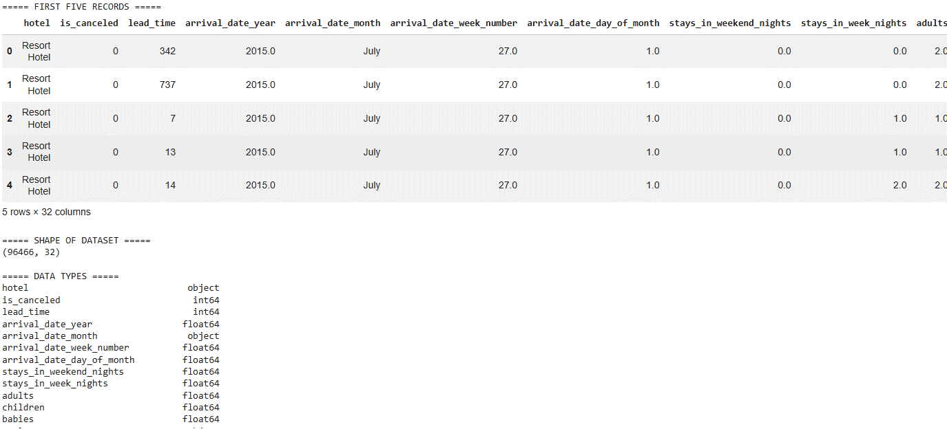

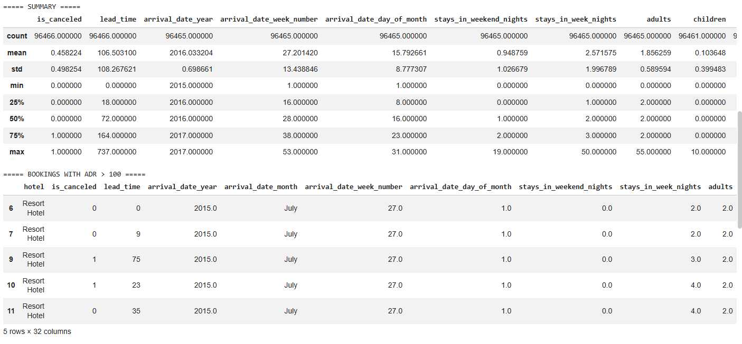

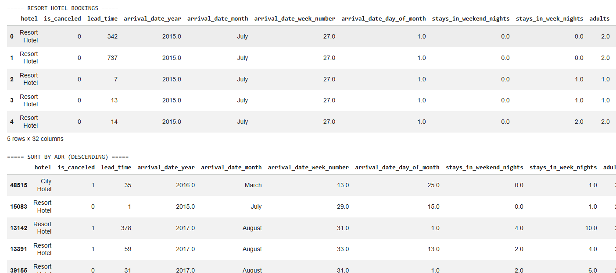

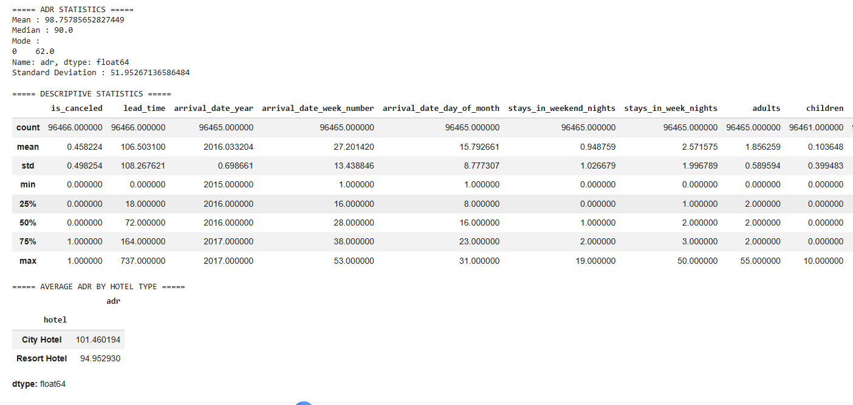
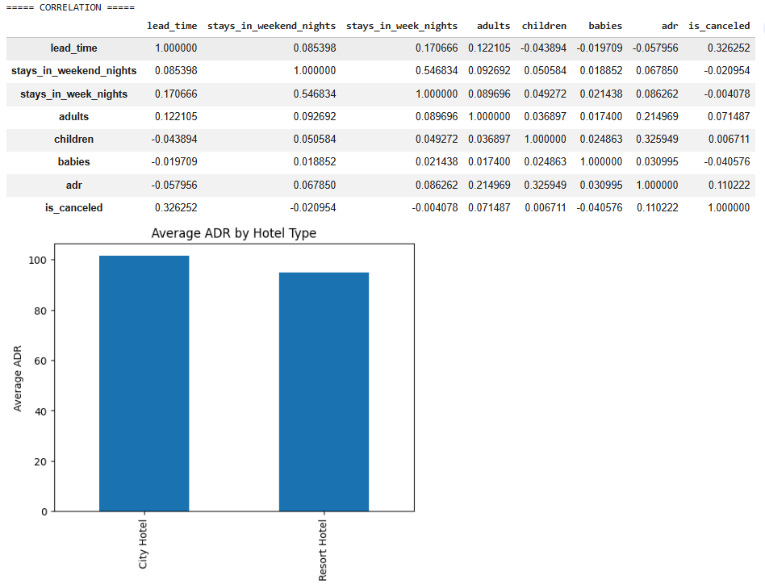
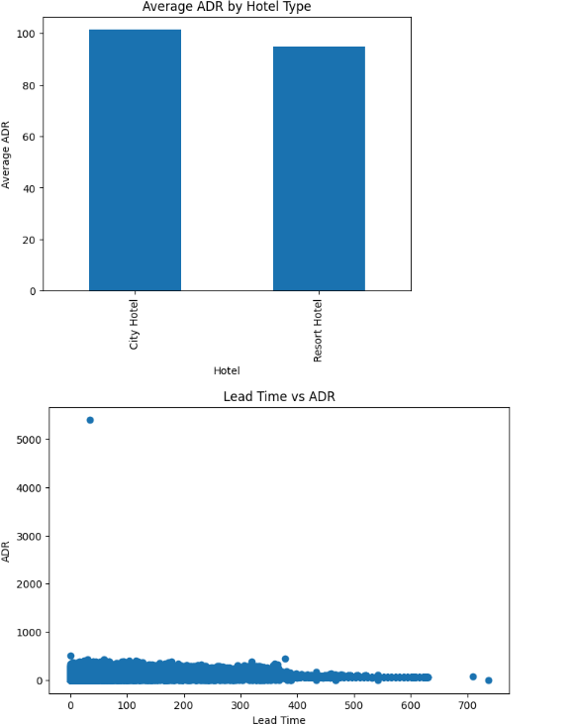

Result:

